MONIAIVE INITIATIVE

Investing In Ideas:
MONIAIVE COMMUNITY HUB

Development Trust Association Scotland:
MONIAIVE HIGH STREET REGENERATION

Joint Brief Report -
Online “Survey Monkey” Results
Rev A ( March 2016)

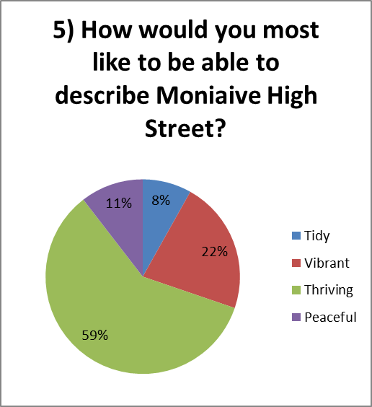

Comments Received for Question 7
please don't forget the daily commuters who pass thru and regularly use shop, garage etc
Anything different from pubs and cafes
post office
none. lift the cones on the double yellow lines! let people know when the high street is shut for festival processions as people have work to go to!
Chip shop
Chip shop :) CatStrand type building/ gym/ sauna/ dance room.
A dedicated space for the Glencairn History Group
Community Share Shop
Housing.
adult outdoor playground gym
Resource centre
none of the above
anything that opens closed units!
Arts hub
Hairdresser
Antiques / Gallery / Workshops / Studios / local info point
a local produce/ product shop.
Art shop
hang-out for teens in village, somewhere they can get together and be responsible for their own space without too much interference and control from adults.
youth centre
Art Centre and a Recycling/Upcyling/Swapping Project
Art Centre and a Recycling/Upcyling/Swapping Project
a community based charity/swap shop
Bakery, clothes shop, DIY, a business
A pop up centre
Arts/crafts gallery/shop space

