MONIAIVE INITIATIVE

MAKING ROOM FOR PEDESTRIANS

Report 1 -
Results of Community Street Audits
November 2017

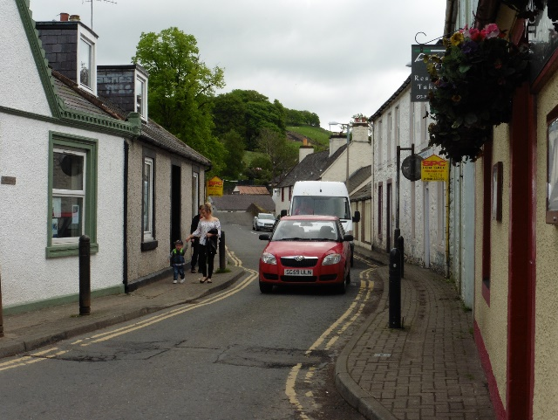

MONIAIVE INITIATIVE
MAKING ROOM FOR PEDESTRIANS
Background
Moniaive Initiative has been working with Living Streets Scotland over the past 6 months through their Lower Speed Communities project. This Scottish Government funded project aims to work with communities where speed has been identified as an issue which is having a negative effect on community life.
This follows on from the work of both Glencairn Community Council and Moniaive Initiative. Glencairn Community Council has been campaigning over the past 5 years to have a 20 mph speed limit introduced outside the primary school. Through its work on the development of the Community Hub and High Street Regeneration, Moniaive Initiative has heard from residents about their concerns about traffic, speed of traffic and the difficulties for pedestrians within the village. Whilst local residents appreciate the importance of much of this traffic to the local economy, they nonetheless feel the need for action to lessen its impact on village life.
As part of the Lower Speed Communities work we have carried out extensive community consultation with residents, parents and school children. This consultation involved a meeting for residents and business owners, meetings with Moniaive Primary School Junior Road Safety Officers, mapping the issues as seen by residents on a large scale map, a Facebook page where residents could leave views and comments, and attendance at the community gala.
The consultation raised a number of concerns:
- Speed of vehicles entering and travelling through the village
- A lack of gateways and adequate signage to alert drivers to the speed limit and that they were entering a village
- The size of some vehicles on narrow streets leading to pedestrians feeling unsafe
- Lack of pavements or very narrow pavements meaning pedestrians being forced to walk on the road
- A lack of safe crossing points
- On street parking meaning that pedestrian sight and routes were difficult
- Lack of safe routes to school
Overwhelmingly, there was support for the introduction of a 20 mph limit within the village. This was seen as contributing to a village where residents and villagers felt safe when walking, would ensure children were able to walk safely on their way to school and when going out to play, and would enhance Moniaive as a positive place to live and to visit.
To support this desire, and in recognition that on its own a 20 mph limit would not resolve all issues raised by residents, a series of street audits tool place.

The Street Audits
Taking its lead from the issues raised in the community consultation, the overall theme for the Street Audit was Moniaive - Making Room for Pedestrians.
The overall aims were to:
- Reinforce priority of ‘place’ throughout Moniaive whilst managing the need for ‘movement’
- Reduce vehicle speeds through the village
- Make streets safer for pedestrians
- Manage parking so it doesn’t impinge on pedestrian space
From the Street Audit it is clear that the best approach will be to treat it as a masterplan with an integrated overall approach consisting of several smaller interventions at key sites, supported by the introduction of a 20 mph limit.
The sites detailed below were selected following the issues raised in the community consultation and in line with the 4 aims stated above. For each site a set of potential actions is proposed which will improve the area. It should be noted that these are potential actions – it is recognised that there needs to be wider community consultation on the acceptability of these actions. They are also not in any priority order. A wide ranging community consultation will be held on the results of the Streets Audits to ensure that residents are able to give their views.

Site 1 - East Entrance to Village and Park
This location has consistently draw comments from local residents regarding the speed of vehicles, both entering and leaving the village. This area produced the highest average speed readings from the village during council monitoring (2016). Speed is a particular concern here because of the proximity to a nearby park entrance, which also provides an off-road route to school. Pedestrians have to cross the road at this point to enter/exit the park, or when alighting from the bus (the park entrance being an unofficial bus stop). The lack of pavement here forces pedestrians to step out into the line of traffic to see oncoming vehicles before crossing.
Potential Actions:
- Create an obvious, visual gateway that clearly tells drivers they are entering a different space - enhanced ‘welcome to Moniaive’ signage, lighting, planters etc
- Restrict road width slightly at entrances to reinforce speed restriction
- Make speed limit signs more obvious including markings on road and pre-warning signs (possible installation of 40mph limit ahead of village entrance to slow speeds gradually and make the transition seem less)
- Set gate to park back and install pavement at park entrance to improve safety
- Install zebra crossing opposite park to provide safe access for bus passengers and park users, and to act as an additional speed deterrent (can be trialled as a temporary DIY exercise with paint)
- Trial alternating parking bays on alternate sides of the road along the Dunreggan road section from the village entrance to the bridge to act as traffic calming and allow safe pulling in spaces, but allow for a continuous pedestrian route (albeit with requirement to cross the road at intervals) without needing to walk into centre of road
- Remove white lines throughout village to deter speeding (this will create the effect of the road being narrower for drivers)
- Recognising that most of the village actually functions as shared space anyway, formalise this by providing a different road surface that looks less like a road
- Build out footway on wide sections of road to deter speeding - especially around Medway/Fell View

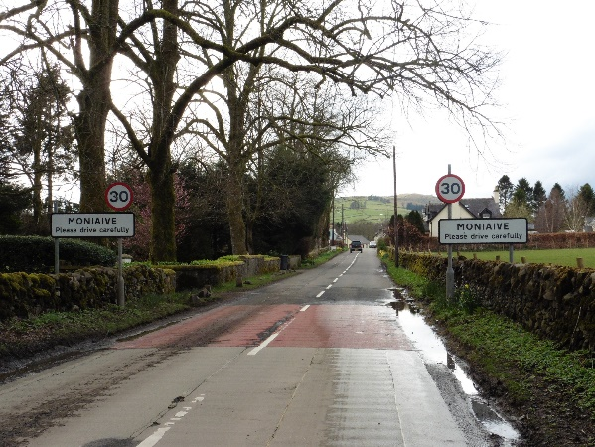

Site 2 - Bridge and George Hotel to Craigdarroch Arms
The ‘bottom end’ of the High Street is the main access into the village for pedestrians from the Dunreggan end of the village, and for those motorists parking in the village car park. The road narrows to single carriageway with priority signage. Parking bays outside the George Hotel slows traffic entering the one-way section, but also reduces space available for vehicles to pull in to give way to oncoming traffic. Sometimes vehicles pull on to the pavements to pass one another. The pavements themselves are too narrow to allow transit by wheelchairs, buggies, or even an adult walking side-by-side with a child. There are insufficient dropped kerbs, so these users normally share the road space rather than cross backwards and forwards between available pavements.
Potential Actions:
- Improve footway and formalise pedestrian area in front of Dalwhat Garage to provide safe pedestrian route from the car park to the village centre
- Remove 2-3 parking bays in front of George Hotel to allow for installation of proper pavement and help where vehicles are needing to pull in ahead of gateway
- Possible reversal of priority at gateway - make signage clearer
- Extend restricted gateway section right through to the George Hotel to prevent vehicles getting ‘trapped’ due to limited visibility and having to reverse
- Continue shared use surface through this section

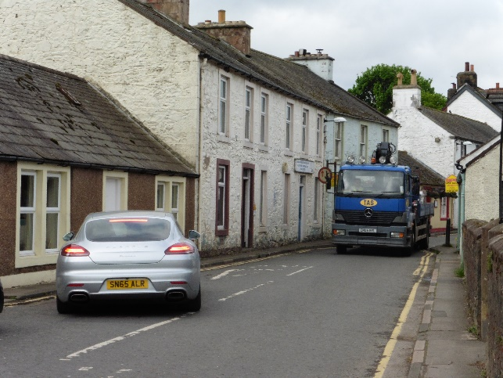

Site 3 - Market Cross and Bus Stop
The centre of the village is a busy crossroads with a steady stream of through-traffic. Because of the narrow street, even legally-parked cars (or buses pulled in to the bus stop) can cause significant disruption. Badly parked cars outside the village shop often block the route for HGV / agricultural traffic, making it difficult for them to negotiate the junction. Pedestrians feel particularly vulnerable when trying to cross the road here, as larger vehicles sometimes have to ride over the pavements to negotiate the corner.
Potential Action:
- Trial end on/diagonal parking outside shop - assess impact on deliveries and parking spaces
- Remove parking bay directly next to junction at end of Chapel Street to allow build out of area around cherry tree - this will provide increased community area and potentially more seating, etc.
- Building out the cherry tree area will lead to a narrower junction mouth at Chapel Street which will help manage vehicle speeds
- North Street - formalise the hatched area at the junction with the High Street as pavement to allow safer pedestrian route at the corner and restrict the width of the junction mouth to reduce vehicle speeds
- Install pavement in front of toilet block and along the wall to stop vehicles parking so close and provide a safer walking route (can be trialled temporarily with paint beforehand)
- Reduce length of pavement where bus shelter is to provide an additional parking bay to replace the one on Chapel Road

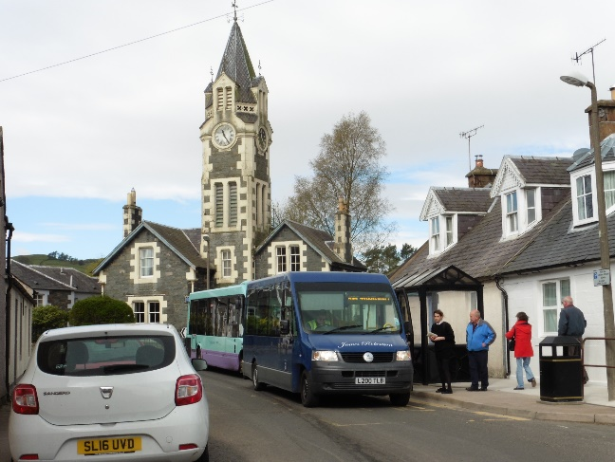

Parking Strategy
Parking availability in Moniaive is limited. Vehicles regularly ‘double-park’ in the village centre, even when there are spaces available in the car park. An influx of vehicles during the tourist season, or for one of the many events held in the village, often results in illegal parking, blocking of pedestrian routes and disturbance of traffic flow.
Potential Actions:
- Ensure that visitors and residents are primarily directed to the public car park to reduce pressure on the high street - introduce signage indicating ‘parking for village’ clearly at entrance to car park and also at west/north ends of village to direct people through.
- Install signage in the car park directing people to key locations in the village with estimated walking times.
- Provide disabled bays only at doctor’s surgery and encourage community enforcement.
- Manage parking in front of residences to allow for safe pedestrian route along building line where possible.

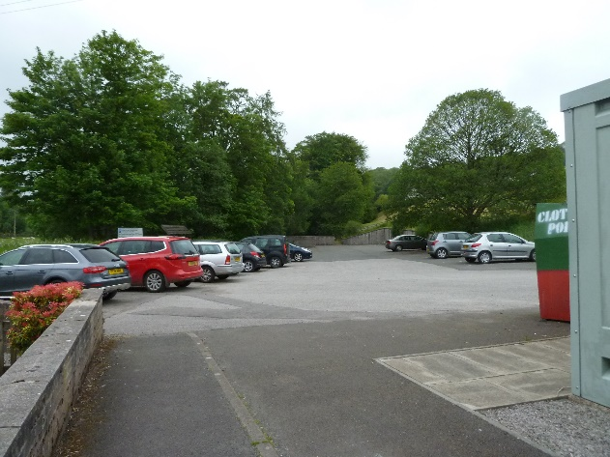

School Audit
A separate exercise was carried out with the Junior Road Safety Officers at Moniaive Primary School, focussing on safe routes to school.
The pupils raised the following issues:
- Lack of pavements, especially near school - not safe for younger pupils
- Parked cars along both sides of road - legal but forces children to walk in middle of road and reduces visibility for crossing
- Traffic travelling too fast - the bigger the vehicle, the faster it feels like it’s going
- Even if vehicles are travelling at 30mph, it feels faster due to lack of safe area to get out of the road
- Lighting generally very good
- Lack of places to play and socialise - streets feel dangerous and no safe routes to parks
- Children unanimously reported not feeling safe with volume, type and speed of vehicles - it was observed that children from the village are used to the traffic so know how to deal with it (even if it isn’t safe) whereas children coming from more rural areas or other villages are not used to it and don’t know how to get out of the way
- Pedestrian routes interrupted by vehicles, lack of pavements and steps to houses
- Children generally liked living in and around Moniaive because it was pretty, green, safe and fairly quiet but they reported that traffic noise, especially from the big farm machinery and logging vehicles was unpleasant
- Chapel Road especially busy with vehicles at school times when people are walking home

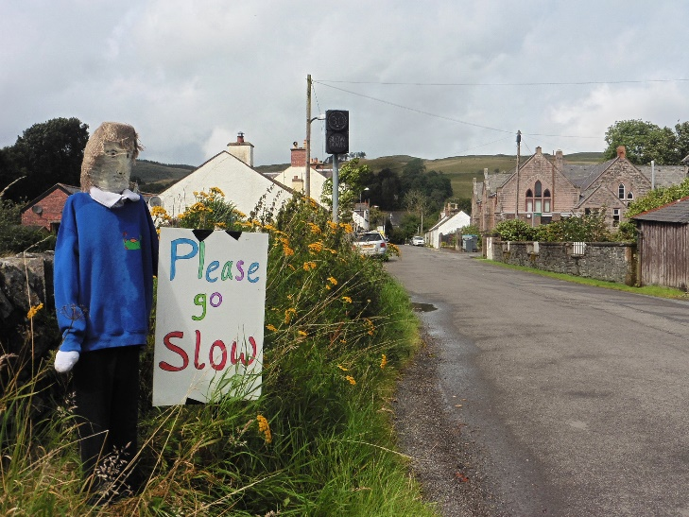

The pupils then focussed on:
Site 1: The Institute
The school uses this building through the week for PE and other activities. Teachers have to stand in the road to stop the traffic, to enable the children to cross safely. Parking outside the Institute makes it difficult to cross safely here, especially when exiting the building. Vehicles entering the village are made aware of the school by signage at the Bridge, but visitors passing through from other directions have no signage, when entering Chapel Street, to warn them they are approaching a school.
Potential Actions:
- Install markings to prevent cars parking directly outside the Institute gateway - could be trialled with temporary paint initially
- Road markings (or other, non-signage options) to remind drivers of nearby school

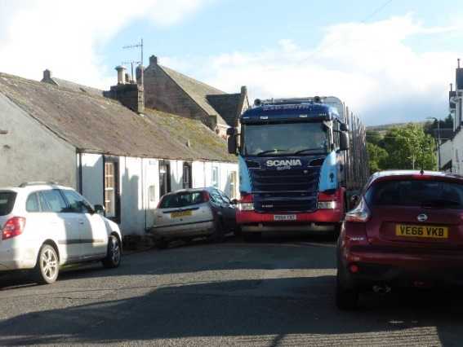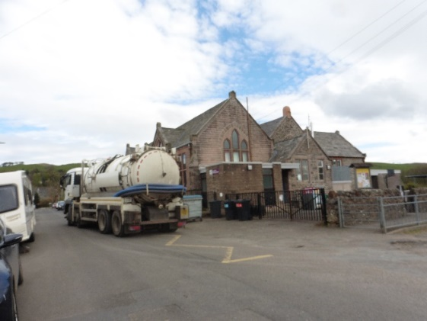
Site 2: School and Turning Place
The private track beside the school, which is used as a drop-off point for the school buses and as a turning place by other vehicles, was identified as dangerous by the children. There are a lot of potholes which make the cars drive unpredictably to avoid them. Parents park here, and thoughtless parking can block the track and prevent the school bus from getting in or out.
Potential Actions:
- Repaving the track to remove potholes and introducing ‘no waiting’ markings at the top end of the track where it meets the road

The junction between Chapel Road and The Grainnes was identified as being particularly dangerous by the children because parents also use this for turning. Children reported that reversing vehicles felt particularly dangerous here, due to the angle of the road and the limited sightlines (both for pedestrians and vehicles).

Site 3: Bridge Entrance to Village
There is an electronic 30mph speed sign, but it has been switched off. Children reported that it wasn’t that effective even when it did work because it is small and people don’t see it.
Overgrown foliage on the bank is obscuring the 30mph signs and preventing children from being able to climb up the bank to move out of the way of large vehicles.
Children unanimously felt that vehicles speed along this section up to the school. There is also evidence that vehicles drive onto the verges to pass other vehicles, even if children are using them as a refuge.
Potential Actions:
- Cut back overgrown foliage to provide clear sightlines to existing 30mph signage
- Supplement ‘school’ signage with additional ‘go slow’ signage
- Road markings (or other, non-signage options) to remind drivers of nearby school
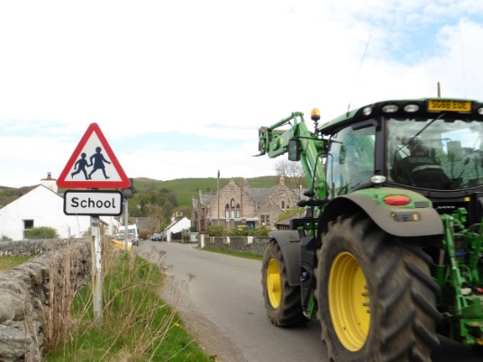
Conclusion
The village of Moniaive has undertaken considerable work through community consultation, mapping, auditing and discussing realistic solutions to the issues facing the village. The issues facing the village are real, and the range of solutions realistic.
Alongside these interventions at specific sites, the village want to see the introduction of a 20 mph limit within the boundaries of the village. Speeds within the core of the village are already within tolerance for the introduction of a 20 mph area.
What Happens Next
A wide ranging consultation will be held with residents to discuss the results of the Streets Audits. It is intended that this will give residents the opportunity to examines the potential actions and give their views on their acceptability – or otherwise – and the reasons for this. From this, potential actions will be prioritised.
Discussions are ongoing with Dumfries and Galloway Council and with elected members to set out the community consultation, the results of this and the village’s desire for the introduction of a 20 mph limit.

