Access Investigation, Path providing access at Barbuie, Moniaive.

Evidence of Use Questionnaire


We are investigating use of the route marked between point A – B on the plan below. If you have any information regarding the use of this route, we would be grateful if you could complete the form below.

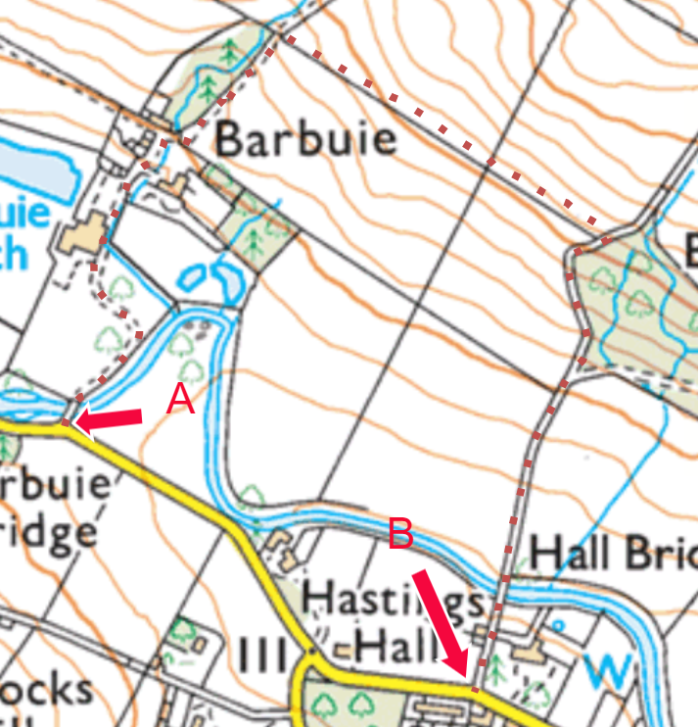

Please complete and return a hard copy to the address at the bottom of the form. Or by email to access@dumgal.gov.uk

Is the route shown above (dashed line A – B) correct Yes No

If not, please mark the correct line that you normally use in coloured pen.
Name…………………………………………… Email……………………………………………………………………………………
Address………………………………………………………………………………………………………………………………………….
………………………………………………………………………………………… Postcode…………………………………………
Any information provided will only be used by Dumfries and Galloway Council to carry out its duties in terms of the Countryside (Scotland) Act 1967 and The Land Reform (Scotland) Act 2003 and will not be disclosed to any third parties without your express permission. More details of how we will use your data can be found at Privacy statement - Dumfries and Galloway Council (dumgal.gov.uk)

Please answer the following questions as fully as possible. If you need to use additional sheets of paper, please attach them to this questionnaire.
1. Year of first use of the route ................................ Year of last use of the route .................................

2. How frequently do you use the route? Daily ⁮ Weekly Monthly
Other: ……………………………………………………………………………………………………………………………………….

3. Do you use the route by: Horse Foot Bicycle
Other: ............................................................................................................................................

4. Why do you use the route and what benefits does it provide: Access Exercise Dog Walking Recreation Short Cut other use or benefit ……………………………………………………………

5. Have you ever asked permission to use the route? Yes No
If yes, when did you ask for it, who did you ask and what was the response? ...................................................................................................................................................................................................................................................................................................................................................

6. Has the route been obstructed, or have you been deterred from using the route by signs/obstacles?
Yes No
If yes, (1) please indicate location of obstruction on the plan and (2) provide details of what way, when, for how long, and if you continued to use the route? ........................................................................................................................................................................................................................................................................................

7. Has anybody ever stopped you using the route? Yes No
If yes, when, who stopped you and how? Did you continue to use the route after this?
……………………………………………………………………………………………………………………………………………………………………………………………………………………………………………………………………………………………………………….......................................................

8. Have you ever been required by your employment to use this route? Yes No
(E.g. because you are a minister or post office worker/delivery courier)
9. Have you ever been employed by, or were ever a tenant of, the owner of the land over which the route passes? Yes No
If yes give details……………………………………………………………………………………………………………….

10. Are you aware of any periods of disuse over the last 40 years? Yes No
If yes, please give details and the length of time the route was disused for:
……………………………………………………………………………………......................................................

11. Please note any other information that you may consider to be useful including other sources e.g. title deeds, maps, other records: ……………………………………………………………………………………………………………………………………………………………………………………………………………………………………………………………………………………………………………………………………………………………………………………………………………………………………………………………………………………………………………………………………………………

12.Do you agree to your details and information above being disclosed to the landowner? Yes No

13. Would you be prepared to give evidence in court if necessary? Yes No

Please return the completed questionnaire to the address below or to the email address. Further copies of the questionnaire can be obtained on request using the details below.
By post to:
Countryside Access Officer
Environment Team
Dumfries & Galloway Council
Kirkbank House
English Street
Dumfries
DG1 2HS

By Email to access@dumgal.gov.uk

All completed forms should be submitted by ………………………………….

Any enquires regarding the form should be sent to access@dumgal.gov.uk

Please ensure you have signed and dated the form and any other attached information.

